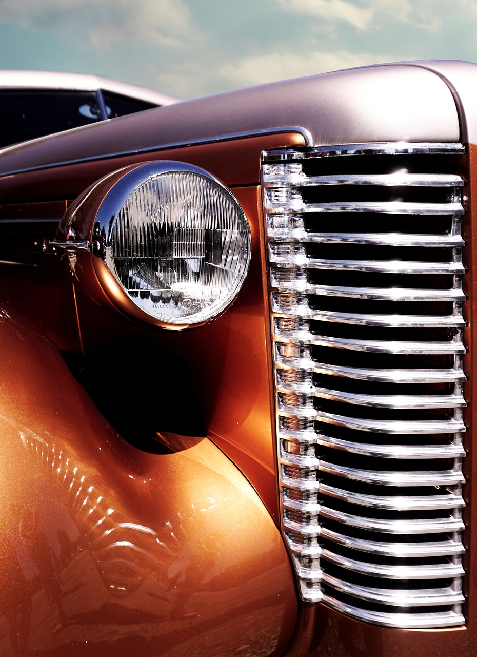

**Source is fictional**

Volume and issue numbers

Year and month of publication

Magazine name

Summer Road Trip

Rides, RANKED!

**Our expert teaches you how to find out all of the facts before you buy**

LEARN YOUR VEHICLE’S HISTORY

June 2015

AUTO

AFICIONADO

Volume 6, Issue 2